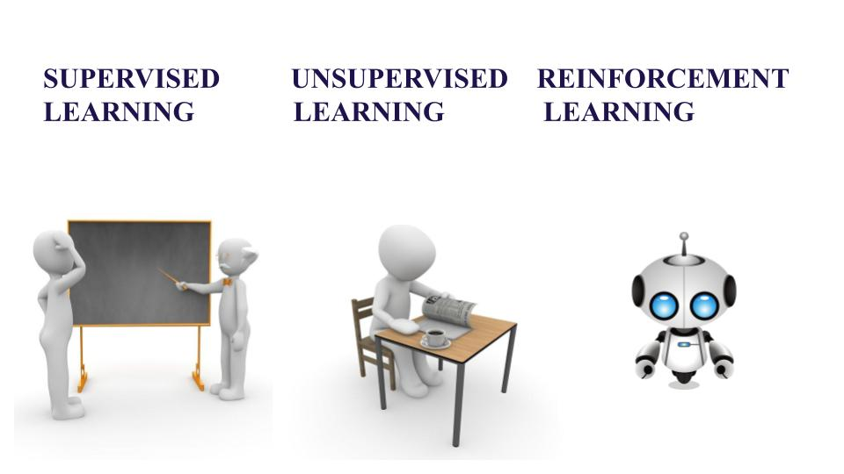

The amount of data generated in the world today is very huge. This data is generated not only by humans but also by smartphones, computers and other devices. Based on the kind of data available and a motive present, certainly, a programmer will choose how to train an algorithm using a specific learning model.

Machine Learning is a part of Computer Science where the efficiency of a system improves itself by repeatedly performing the tasks by using data instead of explicitly programmed by programmers. Further let us understand the difference between three techniques of Machine Learning- Supervised, Unsupervised and Reinforcement Learning.

**Supervised Learning**

Consider yourself as a student sitting in a classroom wherein your teacher is supervising you, **“how you can solve the problem”** or **“whether you are doing correctly or not”**. Likewise, in Supervised Learning input is provided as a **labeled dataset,** a model can learn from it to provide the result of the problem easily.

**Types of Problems**

Supervised Learning deals with two types of problem- **classification problems** and **regression problems**.

**Classification problems**

This algorithm helps to predict a discrete value. It can be thought, the input data as a member of a particular class or group. For instance, taking up the photos of the fruit dataset, each photo has been labeled as a mango, an apple, etc. Here, the algorithm has to **classify** the new images into any of these categories. Examples:

* Naive Bayes Classifier
* Support Vector Machines
* Logistic Regression

**Regression problems**

These problems are used for continuous data. For example, predicting the price of a piece of land in a city, given the area, location, number of rooms, etc. And then the input is sent to the machine for calculating the price of the land according to previous examples. Examples-

* Linear Regression
* Nonlinear Regression
* Bayesian Linear Regression

**Unsupervised Learning**

This learning algorithm is completely opposite to Supervised Learning. In short, there is **no complete and clean labeled dataset in unsupervised learning**. Unsupervised learning is self-organized learning. Its main aim is to explore the underlying patterns and predicts the output.  Here we basically provide the machine with data and ask to look for hidden features and cluster the data in a way that makes sense. Example

* K – Means clustering
* Neural Networks
* Principal Component Analysis

**Reinforcement Learning**

It is neither based on supervised learning nor unsupervised learning. Moreover, here the algorithms learn to react to an environment on their own. It is rapidly growing and moreover producing a variety of learning algorithms. These algorithms are useful in the field of Robotics, Gaming etc.

For a learning agent, there is always a start state and an end state. However, to reach the end state, there might be a different path. In Reinforcement**Learning Problem** an **agent** tries to manipulate the **environment**. The agent travels from one **state**to another. The agent gets the **reward** (appreciation) on success but will **not receive any reward**or appreciation on failure. In this way, the agent learns from the environment.

**Key Differences Between Supervised vs. Unsupervised Learning vs. Reinforcement Learning**

1. Supervised Learning deals with two main tasks Regression and Classification. Unsupervised Learning deals with clustering and associative rule mining problems. Whereas Reinforcement Learning deals with exploitation or exploration, Markov’s decision processes, Policy Learning, Deep Learning and value learning.
2. Supervised Learning works with the labeled data and here the output data patterns are known to the system. But, the unsupervised learning deals with unlabeled data where the output is based on the collection of perceptions. Whereas in Reinforcement Learning Markov’s Decision process- the agent interacts with the environment in discrete steps.
3. The name itself says, Supervised Learning is highly supervised. And Unsupervised Learning is not supervised. As against, Reinforcement Learning is less supervised which depends on the agent in determining the output.
4. The input data in Supervised Learning in labeled data. Whereas, in Unsupervised Learning the data is unlabeled. The data is not predefined in Reinforcement Learning.
5. Supervised Learning predicts based on a class type. Unsupervised Learning discovers underlying patterns. And in Reinforcement Learning, the learning agent works as a reward and action system.
6. Supervised learning maps labeled data to known output. Whereas, Unsupervised Learning explore patterns and predict the output. Reinforcement Learning follows a trial and error method.
7. To sum up, in Supervised Learning, the goal is to generate formula based on input and output values. In Unsupervised Learning, we find an association between input values and group them. In Reinforcement Learning an agent learn through delayed feedback by interacting with the environment.

### Comparison Table

|  |  |  |  |
| --- | --- | --- | --- |
| **Criteria** | **Supervised ML** | **Unsupervised ML** | **Reinforcement ML** |
| Definition | Learns by using labeled data | Trained using unlabeled data without any guidance. | Works on interacting with the environment |
| Type of data | Labeled data | Unlabeled data | No – predefined data |
| Type of problems | Regression and classification | Association and Clustering | Exploitation or Exploration |
| Supervision | Extra supervision | No supervision | No supervision |
| Algorithms | Linear Regression, Logistic Regression, SVM, KNN etc. | K – Means, C – Means, Apriori | Q – Learning, SARSA |
| Aim | Calculate outcomes | Discover underlying patterns | Learn a series of action |
| Application | Risk Evaluation, Forecast Sales | Recommendation System, Anomaly Detection | Self-Driving, Cars, Gaming, Healthcare |

# Artificial Neural Network - Basic Concepts

Neural networks are parallel computing devices, which is basically an attempt to make a computer model of the brain. The main objective is to develop a system to perform various computational tasks faster than the traditional systems. These tasks include pattern recognition and classification, approximation, optimization, and data clustering.

## What is Artificial Neural Network?

Artificial Neural Network (ANN) is an efficient computing system whose central theme is borrowed from the analogy of biological neural networks. ANNs are also named as “artificial neural systems,” or “parallel distributed processing systems,” or “connectionist systems.” ANN acquires a large collection of units that are interconnected in some pattern to allow communication between the units. These units, also referred to as nodes or neurons, are simple processors which operate in parallel.

Every neuron is connected with other neuron through a connection link. Each connection link is associated with a weight that has information about the input signal. This is the most useful information for neurons to solve a particular problem because the weight usually excites or inhibits the signal that is being communicated. Each neuron has an internal state, which is called an activation signal. Output signals, which are produced after combining the input signals and activation rule, may be sent to other units.

## Model of Artificial Neural Network

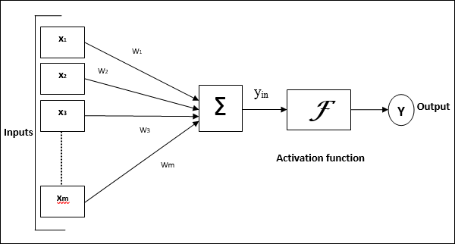

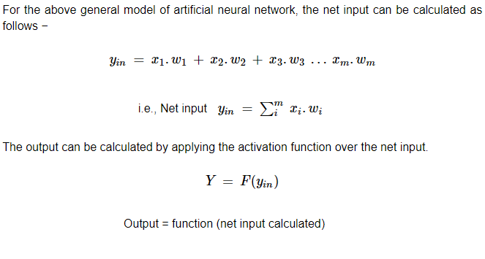

Processing of ANN depends upon the following three building blocks −

* Network Topology
* Adjustments of Weights or Learning
* Activation Functions

In this chapter, we will discuss in detail about these three building blocks of ANN

**Network Topology**

A network topology is the arrangement of a network along with its nodes and connecting lines. According to the topology, ANN can be classified as the following kinds −

**Feed forward Network**

It is a non-recurrent network having processing units/nodes in layers and all the nodes in a layer are connected with the nodes of the previous layers. The connection has different weights upon them. There is no feedback loop means the signal can only flow in one direction, from input to output. It may be divided into the following two types −

* **Single layer feed forward network** − the concept is of feed forward ANN having only one weighted layer. In other words, we can say the input layer is fully connected to the output layer.

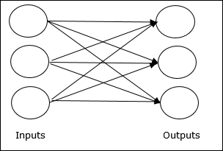

* **Multilayer feed forward network** − the concept is of feed forward ANN having more than one weighted layer. As this network has one or more layers between the input and the output layer, it is called hidden layers.

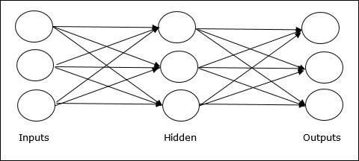

### Feedback Network

As the name suggests, a feedback network has feedback paths, which means the signal can flow in both directions using loops. This makes it a non-linear dynamic system, which changes continuously until it reaches a state of equilibrium. It may be divided into the following types −

* **Recurrent networks** − They are feedback networks with closed loops. Following are the two types of recurrent networks.
* **Fully recurrent network** − It is the simplest neural network architecture because all nodes are connected to all other nodes and each node works as both input and output.

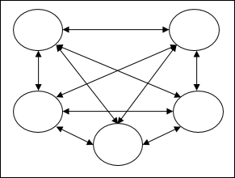

* **Jordan network** − It is a closed loop network in which the output will go to the input again as feedback as shown in the following diagram.

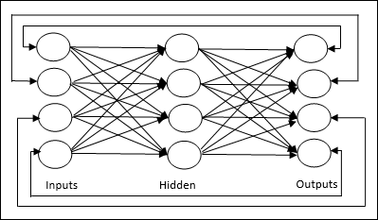

## Adjustments of Weights or Learning

Learning, in artificial neural network, is the method of modifying the weights of connections between the neurons of a specified network. Learning in ANN can be classified into three categories namely supervised learning, unsupervised learning, and reinforcement learning.

### Supervised Learning

As the name suggests, this type of learning is done under the supervision of a teacher. This learning process is dependent.

During the training of ANN under supervised learning, the input vector is presented to the network, which will give an output vector. This output vector is compared with the desired output vector. An error signal is generated, if there is a difference between the actual output and the desired output vector. On the basis of this error signal, the weights are adjusted until the actual output is matched with the desired output.

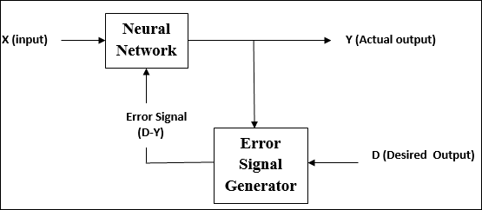

### Unsupervised Learning

As the name suggests, this type of learning is done without the supervision of a teacher. This learning process is independent.

During the training of ANN under unsupervised learning, the input vectors of similar type are combined to form clusters. When a new input pattern is applied, then the neural network gives an output response indicating the class to which the input pattern belongs.

There is no feedback from the environment as to what should be the desired output and if it is correct or incorrect. Hence, in this type of learning, the network itself must discover the patterns and features from the input data, and the relation for the input data over the output.

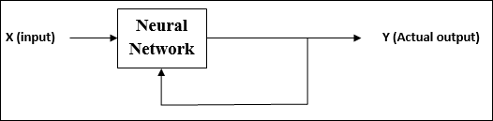

### Reinforcement Learning

As the name suggests, this type of learning is used to reinforce or strengthen the network over some critic information. This learning process is similar to supervised learning, however we might have very less information.

During the training of network under reinforcement learning, the network receives some feedback from the environment. This makes it somewhat similar to supervised learning. However, the feedback obtained here is evaluative not instructive, which means there is no teacher as in supervised learning. After receiving the feedback, the network performs adjustments of the weights to get better critic information in future.

